Original Image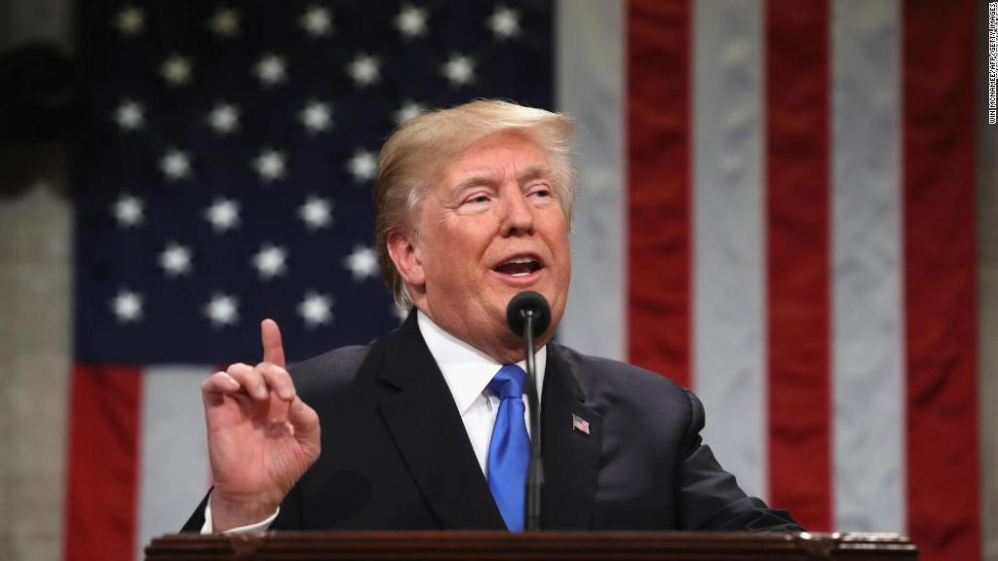

Change #1 Image Cropped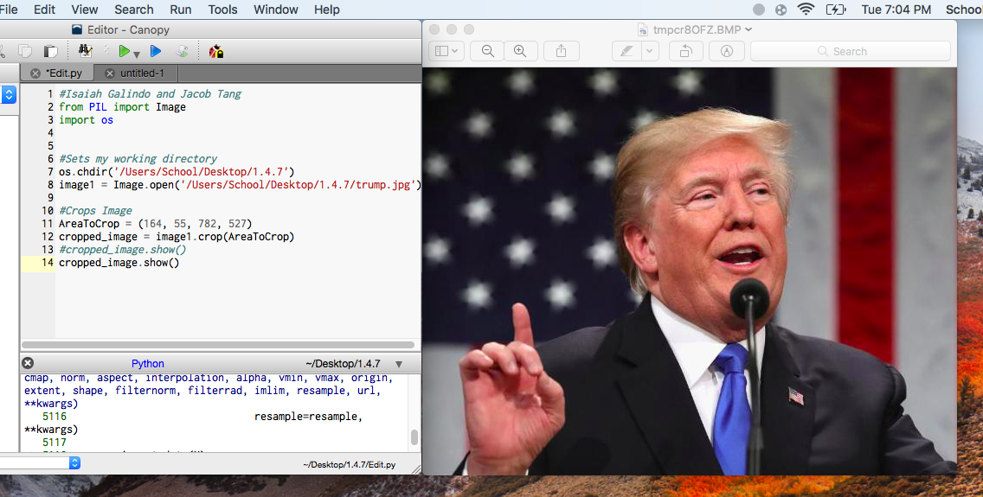

Change #2 We added an Angels Halo over Trump’s head

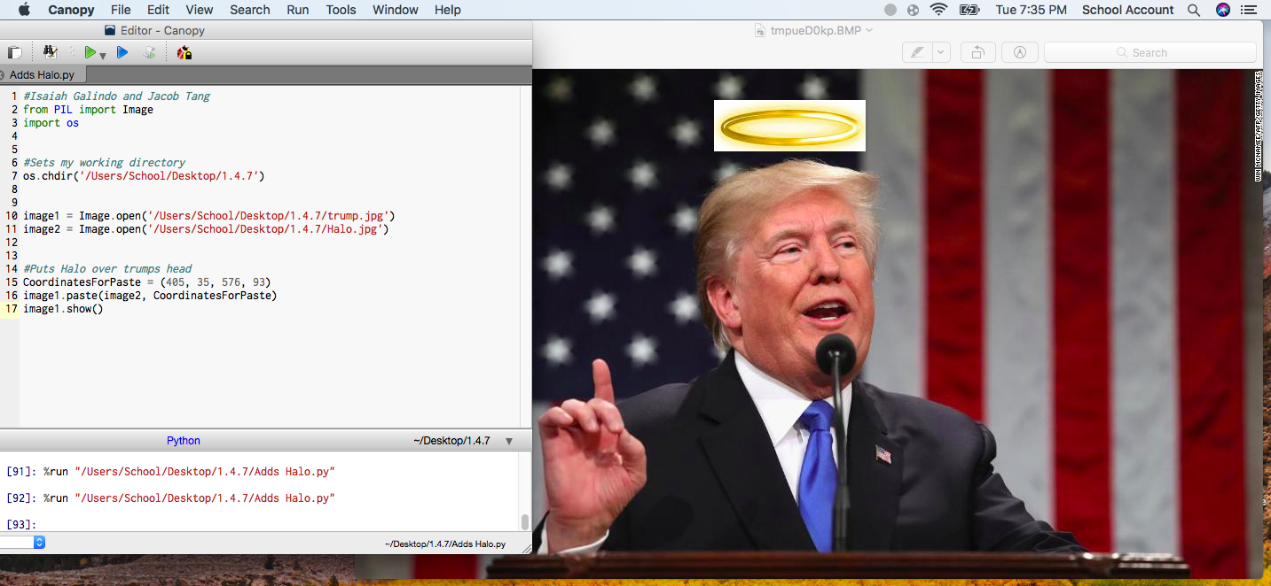

Change #3 We rotate the original image

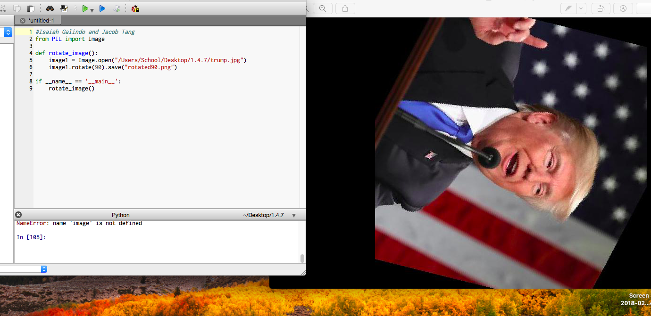

Change #4 We blurred the image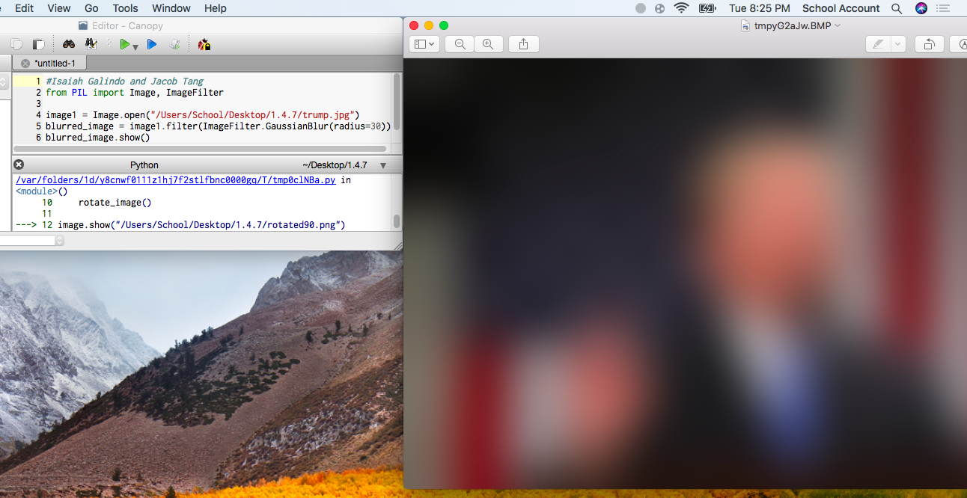

Change #5 We changed the red stripes in the American flag to a different color